**PRACTICAL NO 4**

**Aim:** Demonstration of Hypothesis Testing

**Theory**: Explain Hypothesis testing.

Hypothesis testing is a form of statistical inference that uses data from a sample to draw conclusions about a population parameter or a population probability distribution.

First, a tentative assumption is made about the parameter or distribution. This assumption is called the null hypothesis and is denoted by H0.

An alternative hypothesis (denoted Ha), which is the opposite of what is

stated in the null hypothesis, is then defined.

The hypothesis-testing procedure involves using sample data to

determine whether or not H0 can be rejected.

If H0 is rejected, the statistical conclusion is that the alternative

hypothesis Ha is true.

For example, assume that a radio station selects the music it plays based on the assumption that the average

age of its listening audience is 30 years.

To determine whether this assumption is valid, a hypothesis test could

be conducted with the null hypothesis given as H0: μ = 30 and the alternative hypothesis given as Ha: μ ≠ 30.

Based on a sample of individuals from the listening audience, the sample mean age, x̄, can be computed and

used to determine whether there is sufficient statistical evidence to reject H0. Conceptually, a value of the sample mean that is “close” to 30 is consistent with the null hypothesis, while a value of the sample mean that is “not close” to 30 provides support for the alternative hypothesis.

What is considered “close” and “not close” is determined by using the sampling distribution of x̄.

Ideally, the hypothesis-testing procedure leads to the acceptance of H0 when H0 is true and the rejection of H0 when H0 is false.

Unfortunately, since hypothesis tests are based on sample information, the possibility of errors must be considered. A type I error corresponds to rejecting H0 when H0 is actually true, and a type II error corresponds to accepting H0 when H0 is false.

The probability of making a type I error is denoted by α,

and the probability of making a type II error is denoted by β.

Hypothesis tests are also conducted in regression and correlation analysis to determine if the regression relationship and the correlation coefficient are statistically significant.

A goodness-of-fit test refers to a hypothesis test in which the null hypothesis is that the population has a specific probability distribution, such as a normal probability distribution. Nonparametric statistical methods also involve a variety of hypothesis- testing procedures.

# Output:

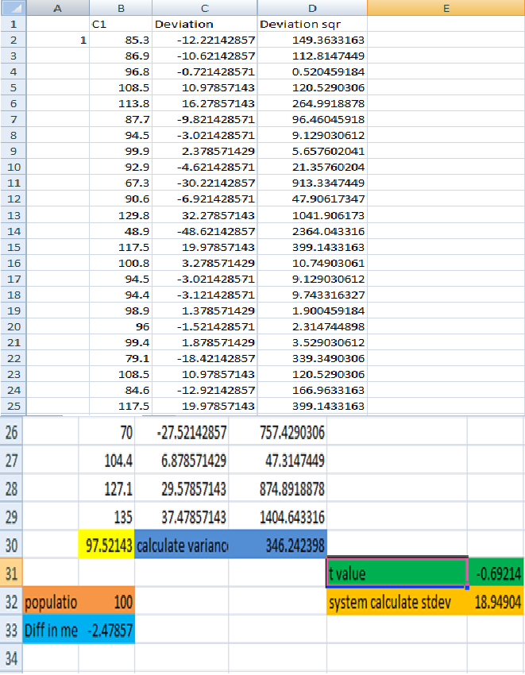

**Step 2:**Now we have to import Excel file (onetest.csv) type bellow command. #datanew=read.csv("D:/onettest.csv")

#datanew

# Output:

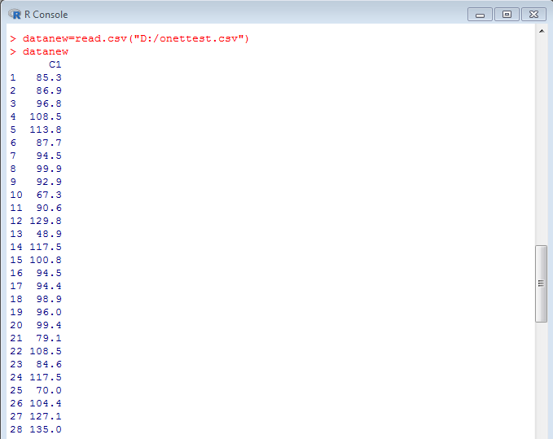

**Step 3:** After importing onetest.csv file we will plot Boxplot diagram type bellow command. #boxplot(datanew)

# Output:

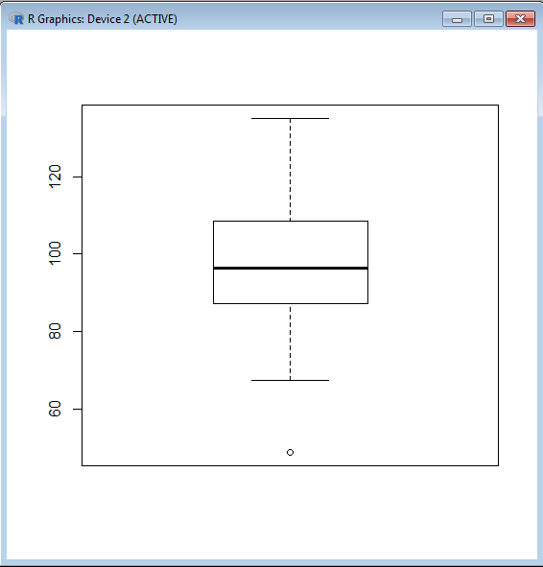

**Step 4:**After that find mean of respective data.

# m1=mean(datanew$C1) #m1

# Output:



**Step 5:**Now calculate the standard deviation. #sd1=sd(datanew$C1)

#sd1

# Output:

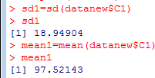

**Step 6:**Plot bell curve. # plot(datanew$C1) **Output:**

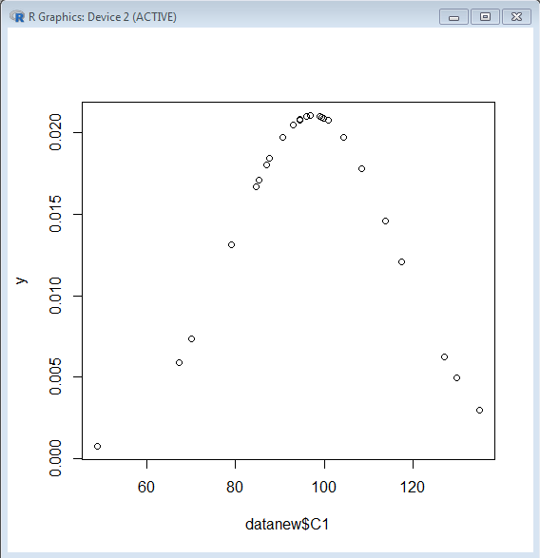

**Step 7:** At the end find T-Test value type following command. #t.test(datanew$C1,alternative="greater",mu=100)

**Output:**

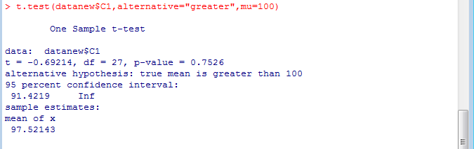

**CONCLUSION:** Thus we have implemented Hypothesis testing of a Single Population means successfully